INSERT YOUR ORGANIZATIONS LOGO

SIGN UP TO BECOME
VOTE READY!
Check off what you need to be:
VOTE READY:
Help me check my registration

Please provide your full name and address so we can provide you with specific information about your local races.

YOUR VOICE MATTERS!

FIRST & LAST NAME

PHONE NUMBER

EMAIL ADDRESS

Send me information about races on my ballot
Remind me of important dates and deadlines
Send me polling place information
Send me information about voting by mail
Other (write-in):

We will never sell your information to a third party. By providing the information above, I consent to receiving nonpartisan election information and reminders.

Important Dates

Voter Registration Deadline:
*INSERT DEADLINE*

General Election:
*INSERT DEADLINE*

Check your registration, apply for a mail ballot, and get more information about voting and what’s on the ballot at:

*INSERT WEBSITE*
I am Vote Ready:
Registered to vote at my address

Researched what’s on my ballot

Made a plan to vote in-person or by mail

Nudged 3 friends so they vote too! I’m sending the Vote Ready GA link to these people:

1.

2.
3.

Sharing that I am #VoteReady on social media

Date Collected:
NOTES:
OFFICE USE ONLY

This voter:

Filled out a registration form Applied to vote by mail
Question about/discussed voting

Pledge only
*Edit text to add in some details about your organization*
INSERT YOUR
ORGANIZATIONS LOGO

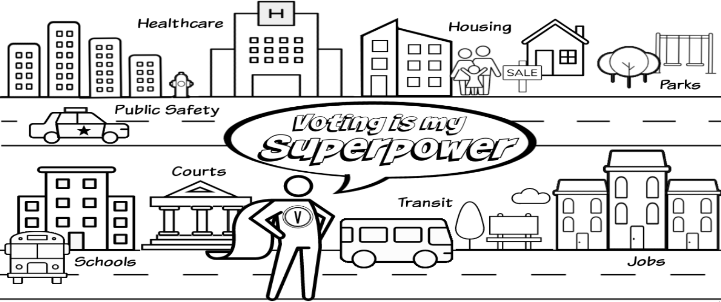
You get a say in who makes decisions about the services in your neighborhood.
Which matter most to you?

