Sign Up and Be Ready to Vote!

The general election is on Nov. 2nd, 2021

You get a say in who makes important decisions about services in your neighborhood.

Which services are most important to you?
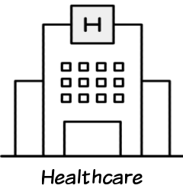 | 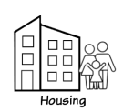
 | 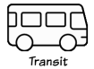 | 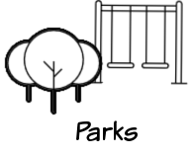

Get the info you need to vote:  _______________________ ________________________  First Name Last Name  ________________________________ ___________  Street Address Apt #  ___________________________ ________________  City Zip Code  ___________________________  Phone Number | Check off what you need to be ready to vote:  - Help me check my registration  - Send information about races on my ballot  - Remind me of important dates  - Send my polling place information  - Send me information about voting by mail

We will never sell your information to a third party. By signing up, you will only receive nonpartisan election reminders for the 2021 elections. You may opt-out at any time.

